Wave Superposition

2017-01-25

Cory Wolfe

Lab Partners: Ryan Goulden and

The purpose of this experiment is to aid in the understanding of how waves add and subtract to eachother. The expected outcome is that two wave's heights will be added together, taking into account the potential negative height to create a resultant wave. This means two waves with maximum amplitudes at the same location will perfectly add, while two waves with maximums shifted one half wavelength from eachother will perfectly subtract, negating eachother if their amplitudes are equal.

In order to complete this experiment will require two speakers, an oscilloscope, two function generators and the appropriate wires to connect them as necessary. In order to complete this experiment a knowledge of waves and how they react when added is necessary. A diagram of the apparatus is shown as Figure Figure. Useful equations include:

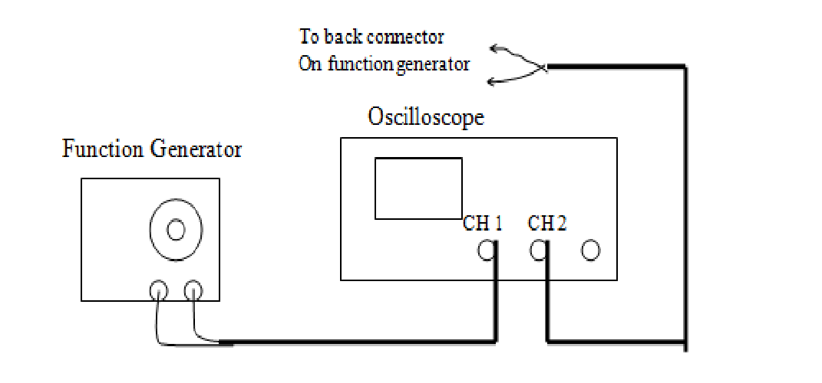  
Figure 1: Diagram of Lab Setup

The procedure for the experiment involved setting up a function generator to ouput a sine wave at three fourths of its maximum output. It was then attached to an oscilloscope where the sine wave was displayed. The wave was set to around 500 Hz and its other relevant data was aquired as shown in Figure 6, along with all other individual data collected in the experiment. This was then repeated for the second channel using the same leads as channel 1. This stage is shown as Figure 2. The two waves were then added to achieve the waves as shown in Figure 3. The waves were then added together and their frequency and amplitude were recorded.

After this channel 2 was reattached to a separate function generator in order to see the effect a square wave would have. The waves were adjusted and then a picture was taken of the waves, this is shown in Figure 4. Then the waves were added. After doing so the period and amplitude were recorded, then a picture was taken. These are visible in Figure 6 and 5, respectively.

After this was completed speakers were attached to the function generators. This allowed the group to hear the changes that were occuring when knobs were turned on the function generator. The frequencies were then adjusted until the waves both stood still on the oscilloscope. After this the function generators were slightly adjusted to allow the group to audibly hear changes, in addition to seeing the addition of the waves.

Then, the oscilloscope was changed to x-y mode to display a Lissajous figure. The settings on the function generator were then changed until the group could determine what the axes were. In addition, the group determined what caused the ring to spin, or say stationary.

The lab functioned as expected. The group determined that the addition of the waves using the oscilloscope confirmed the hypothesis initially presented. The resultant of the waves, both sine or one sine and one square was composed of the addition of the waves height at each point. This was further confirmed as the group adjusted the function generator while in add mode. As the waves were moved into and out of phase the addition principle became more visible.

For the Lissajous figure it was determined that the axes represent the amplitude, with the x-axis measuring the first channel's and the y-axis measuring the second channel's. The figure would spin if the frequencies were not perfectly matched. This is due to the changing amplitudes being graphed with respect to eachother.

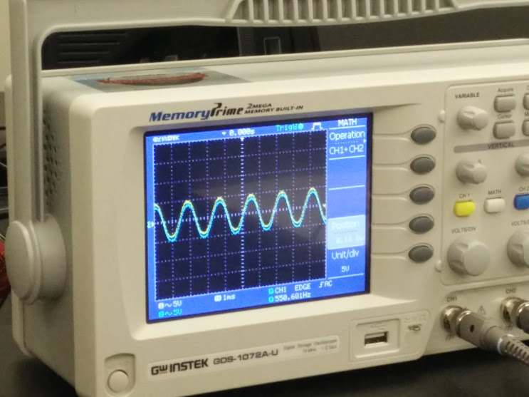  
Figure 2: Same Function Generator On Ch. 1 and 2

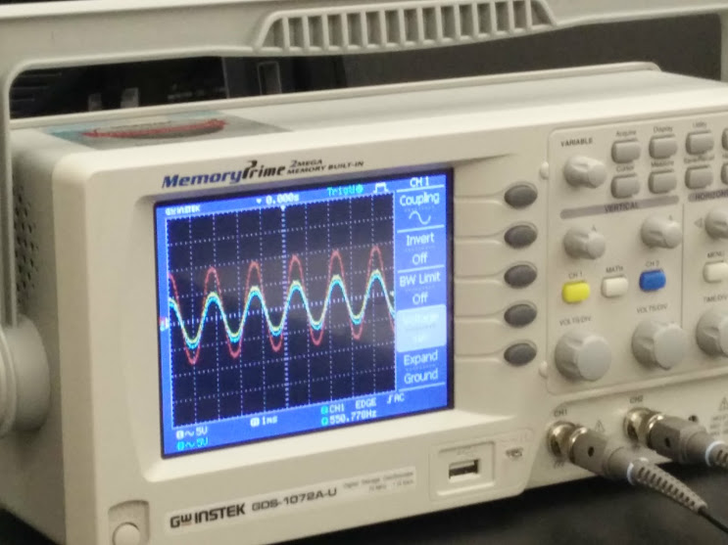  
Figure 3: Adding Waves From Same Function Generator

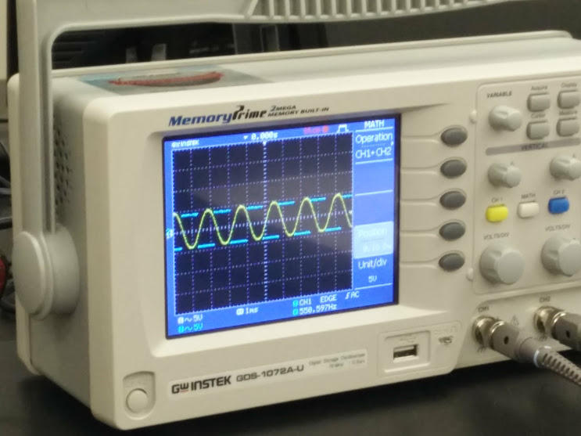  
Figure 4: Square and Sine Waves

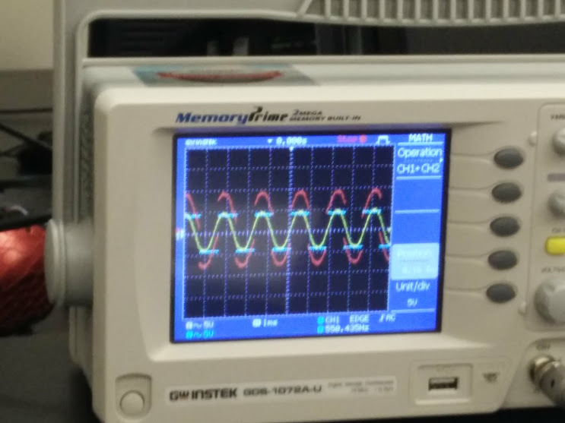  
Figure 4: Square and Sine Waves Added

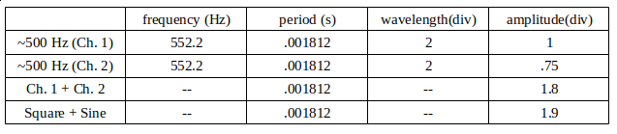  
Figure 6: Table of Data